Experiment 1

Om Hedau

BE-3-25

* $ hadoop fs -ls

It will list available files

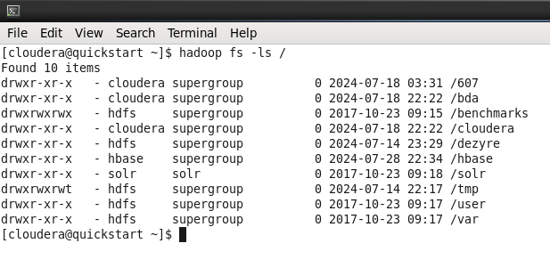

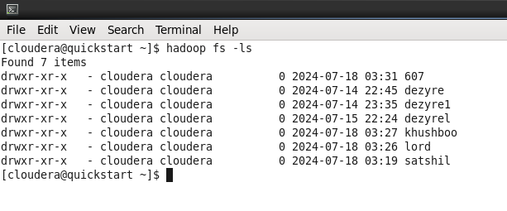

* $ hadoop fs –usage ls

It gives options used with particular hdfs command

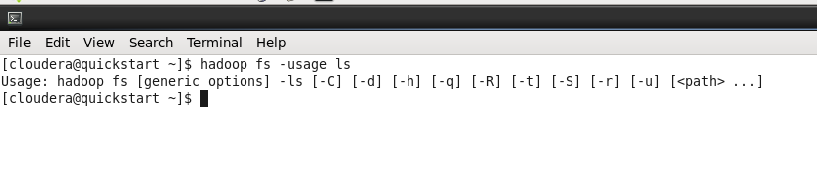

* $ hadoop fs –help

To figure out all the available hadoop commands

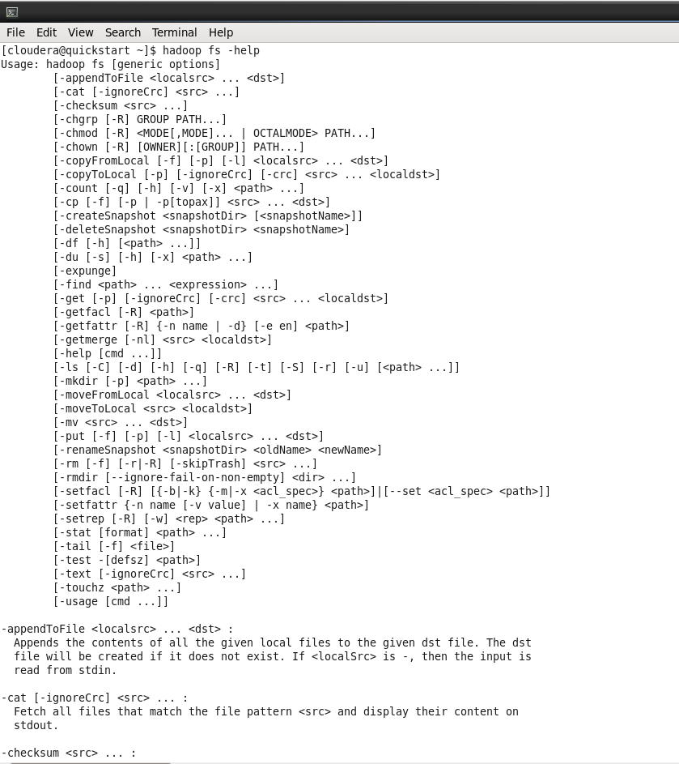

* $ hadoop fs –help ls

Lists usage information along with options

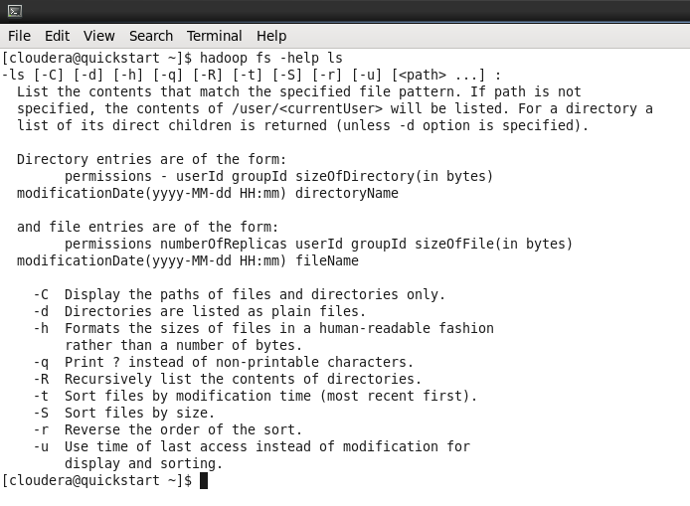

* $ hadoop fs –mkdir /user/cloudera/DF

To create new directory

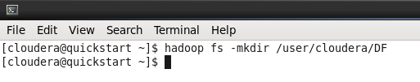

* $ hadoop fs –ls –R /user/cloudera

Returns all available files and subdirectories

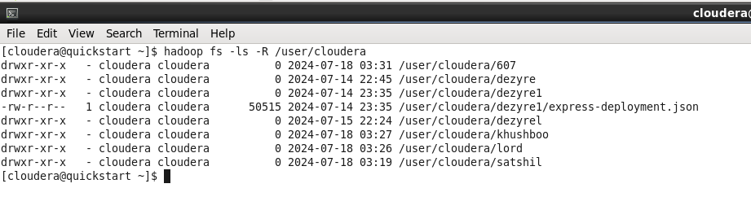

* $ sudo –u hdfs hadoop fs –mkdir /DF

This will create a new directory named ‘DF’

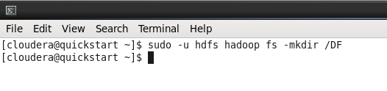

* $ hadoop fs –copyFromLocal Sample1.txt /user/cloudera/DF

Copy/Upload Sample1.txt

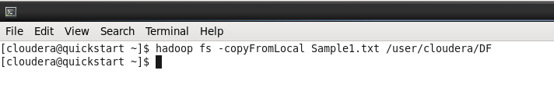

* $ ls

List all files present in the directory



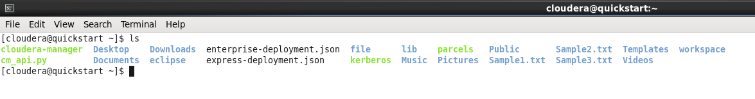

* $ hadoop fs –copyFromLocal Sample2.txt /user/cloudera/DF

Copy/Upload Sample2.txt

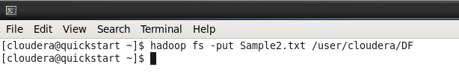



* $ hadoop fs –moveFromLocal Sample3.txt /user/cloudera/DF

Move Sample3.txt

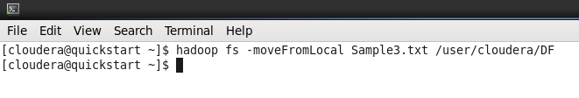

* $ hadoop fs –du /user/cloudera/DF

Display the disk usage for all files

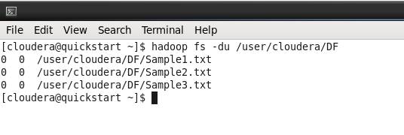

* $ hadoop fs –df

Display disk usage of current hadoop system

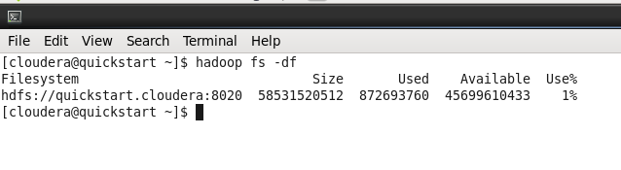

* $ hadoop fs –expunge

It empties the trash by deleting all the files

